The study of buildings physical wear effecting comfortable climate environment in winter

T.A. Duloglu, N.A. Dmitrienko

Institute of services and business (branch) Don state technical University in Shakhty

Abstract: This article deals with the problem of coping with changing climate environment in houses and close ties with wear and tear of buildings. The authors analyze the state of housing stock in town Shakhty and perspectives of improving people’s life quality. For this purpose, a number of full-scale studies were carried out to analyze defects of enclosing structures to prove that they are significantly connected with temperature environment of living quarters. To regulate the basic parameters, the authors choose an integrated monitoring system allowing the researchers to determine a special approach to assessing the buildings’ structure states based on joint result of examining building structure states and air environment.
Keywords: energy-savings, housing stock, wear, controlled environment, enclosing, temperature distribution, housing and communal sector

Since 2000, the urgent problems concerning energy increase saving got special attention. The urgency is confirmed by the Federal Law No. 261, adopted in November 23, 2009, “About Energy Saving and Enhancing Energy Efficiency and Amending Certain Legislative Acts of the Russian Federation" (Federal Law No. 261, adopted on November 23, 2009, "About Energy Saving and Enhancing Energy Efficiency and on Amending Certain Legislative Acts of the Russian Federation"), became the basis of energy saving programs developed for functioning in all municipal formations of the Russian Federation [1].
The above-mentioned area having the largest energy saving potential is considered to be housing stock, with various estimation of energy consumption potential ranging from 30 to 40% of entire energy resources. [2-5] Modernization of housing stock is the most important direction of energy saving and energy efficiency problems. The research will be useful for solving a number of existing problems of housing stock as it intended to increase house life cycles, maintaining comfortable internal climate parameters, equipping buildings, enhancing architectural expressiveness of buildings and at the same time improving the quality of energy efficiency. [6]
Any building during exploitation period is exposed to aggressive environmental effects (having natural and techno gene characters). The results of such influences are initial property changes. [7] So a lot of breach, cracks and solution aeration appeared in buildings proving different degrees of deterioration that can seriously decrease heat insulating qualities of the buildings decreasing internal surface temperatures as to compare with protecting designs. Heat-insulating qualities of protecting designs generally depend on such factors as physical depreciation and moisture appearance.
Housing stock in town Shakhty contain buildings without front facing layers therefore they are available to destructing process appeared in external layers of buildings’ protecting designs made out of silicate bricks. Under real operating conditions, moisture (as snow and rain and condensate) can easily penetrate into basic structures as they are unprotected. Further on moisture is easily concentrated in small pores of houses turning into ice. The active processes lead to enclosure material cracking and moisture penetration into inner layers of buildings, resulting in mold and fungus appearance in houses [8].
Such violations of enclosure operational characteristics decrease thermal conditions in houses, to cope with them additional costs to maintain comfortable temperature in the apartments are required.
In town Shakhty two-third of housing stock has more than 50% of deterioration (Fig. 1). The main characteristics of residential buildings are: aeration of seams, weak walls bricklaying, efflorescence, traces of moistening, and emergence of cracks (VSN 53-86 (p) Rules of assessing physical depreciation of residential buildings). The enclosing structures characteristics can negatively affect the climate environment of the flats, and people want to get rid of constant monitoring, doing repair works.
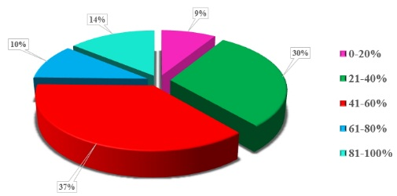
To study physical deterioration effecting indoor temperature control in residential buildings, a thermal image examining multi-apartment house of series C438 was carried out, having enclosing structure deterioration 20% [7] (Fig. 2).
Fig. 1. Condition of housing stock Shakhty
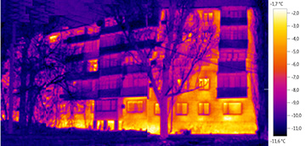
The natural research study let the authors point out the basic ideas that the front parts of the house, and bricklaying parts have some abnormal zones (i.e. the zones with increased temperature appeared on external surface of protecting designs at the expense of ex filtration).
Fig.2. Thermogram of the apartment house
Full-scale inspection of the residential building made possible to assess the air environment parameters in a residential house having centralized heating, in accordance with general thermal comfort requirements. The study of air temperature depends on the hight of a room. The assessment was carried out in outer enclosing structures (Fig. 3,a) and in the central part of the room (Fig. 3,b).
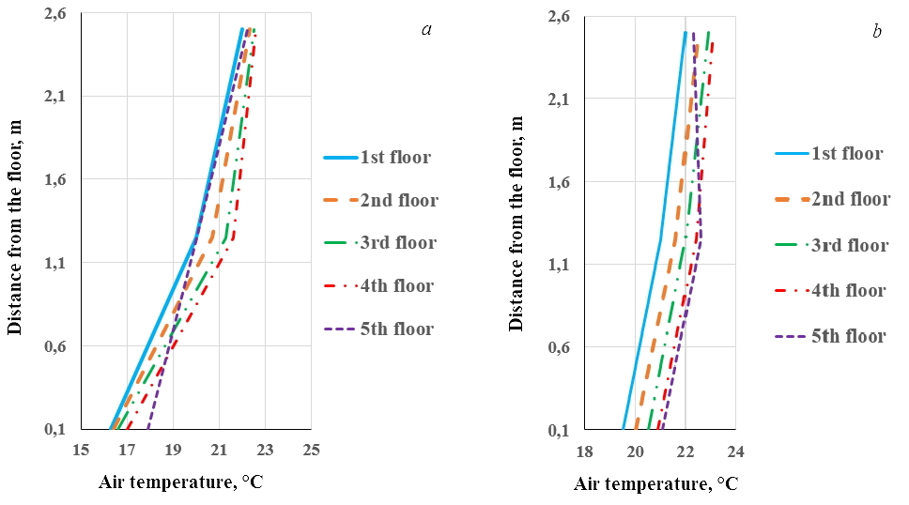
Fig.3.Distribution of air temperature over the height of the room with the wear of the enclosing structures 20%:
a ‒ at the outer wall; b ‒ in the center of the room

According to the idea (GOST 30494-2011 Residential and public buildings. Microclimate parameters in the premises) providing various temperature indicators in various points of the determined zone where temperature may drop to 2 ˚С to compare to optimum temperature indicators while 3 C drop is considered to be admissible for residential flats. The data of the conducted research allow the researchers come to the conclusion that the requirements (GOST 30494-2011 Residential and public buildings. Microclimate parameters in the premises) are satisfied in the central part of the building. But some distribution of temperature indicators can be explained by the height in the zone is of our special interest. The defects in wall designs lead to a considerable deviation of actual temperature indicators from permitted values at the height of 0, 1 m from the floor. This effect can be explained by height infiltration of cold air.
The conducted research allows seeing that temperature differences on the ground and first floors, to show that temperature is lower than admissible. First of all, this is due to the fact that cold air can easily penetrate into the rooms due to cracks and chips of the plaster layers of buildings.
Despite the temperature regulating problems in housing stock, it is possible to correct basic temperature parameters by means of informative support applications, improving design conditions and engineering equipment of buildings [9,10]. The application based on integrated monitoring system of wear and tear conditions of residential building elements can improve energy-saving resources for their restoration.
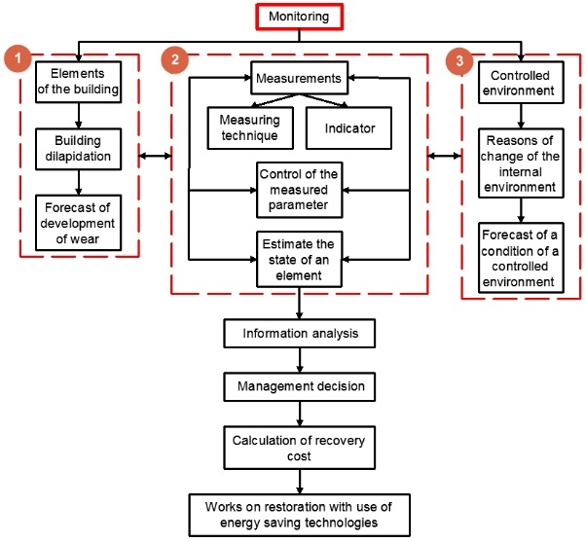
Each block of complex monitoring structures performs the tasks. (Fig. 4) So, the block 1 allows developing the plan of improving technical condition of houses, based on information indicators reflecting physical and obsolescence of both structural elements, and engineering equipment. The received information on monitoring results is entered in the information base on a quarterly basis, with databases updating performed annually.
Fig.4 Structure of complex monitoring of the controlled environment of premises under the influence of operational wear of building elements

The block 2 carries out continuous tracking of temperature environment parameters in rooms and point out the comparison with their standard indicators developing multiple optimizing models of technical condition of buildings, thereby increasing economic and social efficiency of the overhauls.
Finally, the third block, which is supposed to be information and analytical support of the monitoring system, aimed at analyzing the obtained results, so the replacement cost can be calculated, at any stage of buildings’ life cycle determining the necessity of overhauls needs.
Thus, in order to identify the peculiarities of multi-apartment wear and tear houses the standard buildings with series C438 were inspected in details. During the survey, the peculiarities of temperature distribution differences were pointed out, the main characteristics of dependences and peculiarities were stated, the results of enclosing structures defects were obtained. The obtained data prove the supposition and can be significant to improve people’s living conditions and temperature indicators in houses.

References
- Gulabyants L.A. Energy saving. 2016. №1. pp.26-31.
- Dubyagin Yu.P., Dubyagina O.P., Marchenko E.M. Energy saving and water treatment. 2013. V. 83. № 2. pp. 11-16.
- Gorshkov A.S. Engineering and construction magazine. 2010. №1. pp. 9-13.
- Alihodzic, R., V. Murgul, N. Vatin, E. Aronova, V. Nikolić, M. Tanić and D. Stanković, 2014. Renewable energy sources used to supply preschool facilities with energy in different weather conditions. Applied Mechanics and Materials, V.624: pp.604-612.
- Wei, Li, Zh. Jinzhong and Zh. Zhimin, 2012. The Energy-saving Benefit Evaluation Methods of the Grid Construction Project Based on Life Cycle Cost Theory. Energy Procedia, 17: pp. 227-232.
- Zilberova I.Yu, Petrov K.S. Inženernyj vestnik Dona (Rus), 2012, №4. URL: ivdon.ru/magazine/archive/n4p1y2012/1119.
- Ivanchuk E.V. Inženernyj vestnik Dona (Rus), №4. URL: ivdon.ru/ru/magazine/archive/n4y2013/2151.
- Brayla N.V. Engineering and construction magazine. 2012. №1. pp.106-112.
- Shchegolkov A.V., Mishin M.A. Polzunovsky newsletter. 2011. №1. pp.257-264
- Zilberova I.Yu, Petrov K.S., Zilberov R.D. Inženernyj vestnik Dona (Rus), №4 URL: ivdon.ru/ru/magazine/archive/n4p1y2012/1080.

